EQUIPMENT & SUPPLIERS
6.1 Gas Fired Boiler 2
6.2 Radiators 3
6.3 Extract Fan 4
6.4 Controller 5
6.5 Water Meter 6

Gas Fired Boiler
Equipment: | Boiler | 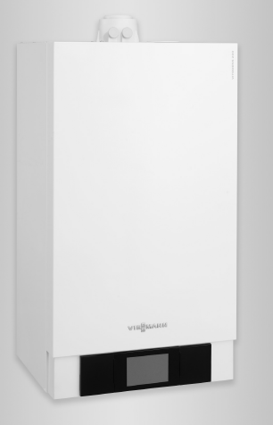
Drawing Reference: | B01
Physical Location: | Boiler Cupboard
Association: | Heating System
Manufacturer: | Viessmann
Telephone: | 01952 675000
Website: | www.viessmann.com
Model: | Vitodens 222F
Type: | Wall hung RSF gas fired condensing combi boiler
Duty: | Rated Output 35kW  Heating Circuit Design Temp: 80°C Flow / 60°C Return
Electrical: | 230V∼1ph∼50hz
Control Strategy: | Wall mounted controller
Safety Comment:
Maintenance: | Annual service by qualified installer.
Spares: | None recommended
Documents: | Installation, User & Service Manual | Section 9 – Index A
Notes:

Radiators
Equipment: | Radiators |  | 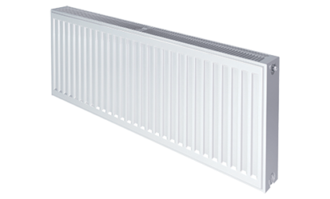
Association: | LTHW Heating System
Drawing Reference:
Physical Location: | As Record Drawings
Manufacturer: | Stelrad
Telephone: | 0844 543 6200
Website: | www.stelrad.com
Model: | Compact, LSTi Plus
Type: | Surface mounted steel panel radiator, water heated
Duty: | Various
Electrical: | n/a
Control Strategy: | Thermostatic radiator valves fitted for individual space control of temperature
Maintenance: | Manufacturer does not identify specific maintenance over and above standard good practice general maintenance noted in Section 5 of this manual.
Spares: | None recommended
Warranty: | Manufacturer’s 10 year warranty, conditions apply http://2jomhg1cupfs2jxnrb3gelkt-wpengine.netdna-ssl.com/wp-content/uploads/2015/02/Warranty-Statement-February-2015-agreed-14-02-15.pdf
Documents: | Technical Datasheet | Section 9 – Index B
Notes:

Extract Fan
Equipment: | Extract Fan | 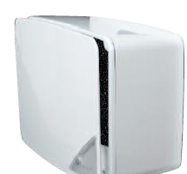
Drawing Reference:
Physical Location: | Ceiling mounted
Association: | Standalone Extract Fans
Manufacturer: | Nuaire
Telephone: | 029 2085 8200
Website: | www.nuaire.co.uk
Model: | Opus 40S-ESPF
Type: | Surface mount inline extract fan
Motor:
Duty:
Electrical: | 230V∼1P&N∼50Hz
Control Strategy: | Trickle ventilation with boost via lightswitch operation
Maintenance: | Inspect and clean (if required) at interval appropriate to installation
Spares: | None recommended
Documents: | Datasheet & Instructions | Section 9 – Index C
Notes:

Controller
Equipment: | Heating Controller | 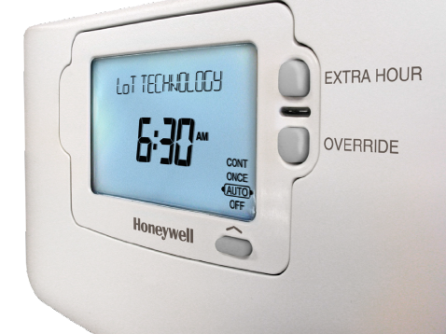
Drawing Reference:
Physical Location: | Boiler Cupboard
Association: | Heating System
Manufacturer: | Honeywell
Telephone: | 08457 678999
Website: | www.honeywelluk.com
Model: | ST9100C
Type: | Electronic 1 day 1 Channel programmer
Motor: | n/a
Duty: | n/a
Electrical: | 230V∼1P&N∼50Hz
Control Strategy:
Maintenance: | None listed
Spares: | None recommended
Documents: | Datasheet & Instructions | Section 9 – Index D
Notes:

Water Meter
Equipment: | Water Meter | 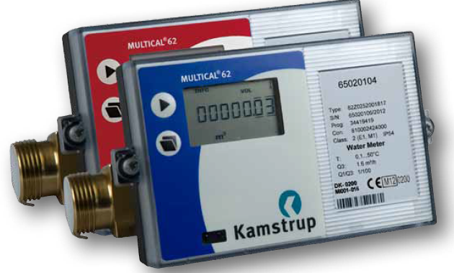
Drawing Reference:
Physical Location:
Association: | Water Services
Manufacturer: | Kamstrup
Telephone: | 01787 319081
Website: | www.kamstrup.com
Model: | Multical 62 Ultrasonic Water Meter
Type:
Motor: | n/a
Duty: | n/a
Electrical: | 230V∼1P&N∼50Hz
Control Strategy:
Maintenance: | None listed
Spares: | None recommended
Documents: | Datasheet & Instructions | Section 9 – Index E
Notes:

