DECLARATION OF CONFORMITY  Nº XGB62426LR |  |  |  |  |  |  | 
DESIGNER | Name: ORONA S.COOP
DESIGNER | Address: Pol.Ind. Lastaola, s/n-20120 Hernani (Guip@uzcoa)
LIFT | Type: Lift M34E
LIFT | Serial number |  |  |  | XGB62426LR | Year of installation: 2017
LIFT | Description: |  |  | Rated speed:1.00 m/s  Levels served:3 |  | Rated Load: Q630 kg  Travel: 6.75 m
LIFT | Location of installation: CHICHESTER (CHICHESTER-)
We herewith declare that this lift, has been designed in conformity with Directive 2014/33/EU and harmonised standard: EN_81_70, EN_81_73, EN81-58 with conformity to 317069 (E-120).
It furthermore complies with directive 2004/108/EC(EMC).
NOTIFIED BODY  (for design) |  |  | Name and Address: LIFTINSTITUUT, Buikslotermeerplein 381,1025 XE - Postbus 36027,1020 MA AMSTERDAM  Identification number: 0400  Annex: IV (Modul B)  EC type Certificate nr.: NL 17-400-1002-035-39

Aditional information

- Lift model EC type examination certificate
- Basic characteristics
- Plans of lift in building
- Electric schematic diagrams
- Safety components list
- Basic characteristics of ropes and chains

- Instructions for normal use and rescue operations
- General maintenance instructions for the lift
- Maintenance instructions for safety components
Design company signature |  | Place: ORONA S.COOP
Name: Itziar Ocaña Sola
Subdirectora de SAC (Servicio de Asistencia al Cliente)
Signature:
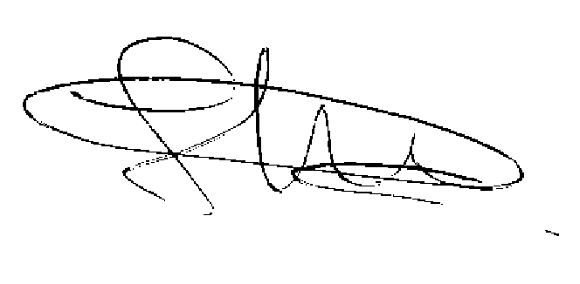

DRAWING GUIDE

INSTALLATION LOCATION DRAWING

(Installation location in its surroundings, indicating fixed references)

LOCATION DRAWING WITHIN BUILDING

(Installation location on building floor)

- INSTALLATION CHARACTERISTIC DRAWINGS
(Drawing content)

- Shaft elevation and cross-section.

- Reserves at top of shaft and in pit.

- Premises below shaft.

- Pit access.

- Reaction on the building and the bottom of the pit.

- Position and principal dimensions of the machine spaces, with the layout of the machine and principle devices. Dimensions of the traction sheave or the drum. Ventilation holes, etc

- Guide anchor location.

- Access of the machine spaces, pulley and main controller box

- Position and principal dimensions of the pulley spaces, if any. Position and dimensions of pulleys.

- Guard between lifts if there are more than one in the same well.

- ELECTRICAL DIAGRAMS

Power and lighting.

Safety circuits.

TECHNICAL DOSSIER

SERIAL Nº: :XGB62426LR | Layout drawing Ref Nº: N401247A

MODEL OR TYPE: Lift M34E | CE MARK: NL 17-400-1002-035-39

INSTALLATION DATA
OWNER: W STIRLAND LIMITED |  |  |  |  |  |  |  |  | CIF:
ADDRESS: CHICHESTER (CHICHESTER-) |  |  |  |  |  |  |  |  | PORTAL Nº:
 |  |  |  |  |  |  |  |  | POSTAL CODE: CP:
Identification of the elevator in the building:

TECHNICAL DATA
Rated Load: Q630 Kg. |  | Rated speed: 1.00 m/s. |  |  |  |  | Location of machinery: At the upper level (Whithout machine room)
Nº of persons: 8 |  | Control speed: Electric wiht vf drive |  |  |  |  | Acces: By door
Nº of levels served: 3 |  | Machine Power: 4.5kW. |  |  |  |  | Roping system: 1:1
Entrance 1:3 |  | Power grid supply: 5.346kW. |  |  |  |  | Landing Door: Automátic / -
Entrance 2: 0 |  | Voltage: VF_415 V. |  |  |  |  | Shaft:.
Total: 3 |  | Nominal current grid:8.264A. |  |  |  |  | Car with: 1100 mm.
Travel: 6.75 m. |  | Number of phases: 3 |  |  |  |  | Car depth: 1400 mm.
Controller: COL_SEL_ARCA |  | Frequency: HZ_50 Hz. |  |  |  |  | Door clearance: 800 mm.
Dead weight: 533 kg. |  | Car guide rail: T-127-L1/A |  |  |  |  | Counterweight guide rail: T-50
SAFETY COMPONENTS |  |  |  |  |  | (Identification, certificate Nº, Notified Body)
Devices for locking landing doors. |  |  |  |  |  | COMPACT, A11/99AU04/FH, AENOR-0099
Devices to prevent the car from falling or uncontrolled movement |  |  |  |  |  | Brake:MAYR Roba Duplostop 8010.__ Size 200, EU-BD 766, TUV 0036  Car:B9_R, NL.09.400.1002.035.17, LIFTINSTITUUT-0400  Counterweight:NO LLEVA  UCMP, Traction,NL 11-400-1002-035-27 , LIFINSTITUT 0400
Overspeed limitation devices |  |  |  |  |  | L250, NL.03.400.1002.035.04, LIFTINSTITUUT-0400
Energy-dissipation or accumulation type shock absorbers |  |  |  |  |  | Car:300-401A,4420812019090,TUV-0044 Counterweight:300-401A,4420812019090,TUV-0044
Safety devices fitted to jacks of hydraulic power circuits where these are used as devices to  prevent falls. |  |  |  |  |  | --
Electric safety devices in the form of safety circuits containing electronic components |  |  |  |  |  | --
FIRE-PROOF DOORS |  |  |  |  |  | ORONA/COMPACT/Warrington 0833/317069 (E-120)
USE |  |  | DRIVE |  |  |  |  | TYPE
Public Building |  |  | Electric |  |  |  |  | Normal
Basic characteristics of ropes and chains
Traction rope (nº/Ø): 5 de 6.5  Construction: ORONA SDR-BRUGG 6x19S+7x7  Breaking strength :23.6kN  Safety factor with >= 3 ropes: According to EC type examination certificate |  |  |  | Overspeed governor: 6 x 19S + FC  Breaking strength : 17140N |  |  |  |  |  | Compensation chain:
OTHER MEASURES  The list of alternative measures is attached as an annex (design review).
 Compensatory measures due to reduced ends: In pit   On last floor
OBSERVATIONS

Signed: _
(Signature of the responsible technician)

